ELECRAFT K3 TYPE 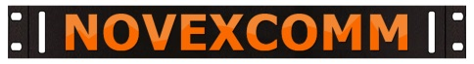MOUNT BRACKETS
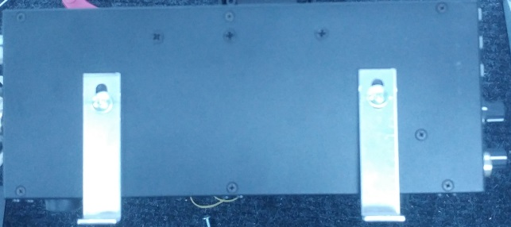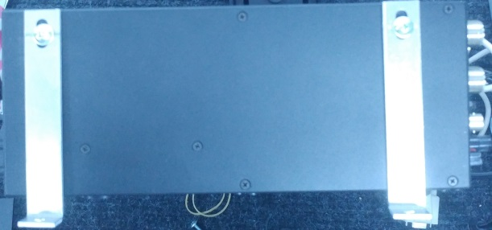
RIGHT SIDE USE
UPPER FEET HOLES

LEFT SIDE USE
HANDLE HOLES

DRILL LEFT HANDLE HOLES & REMOVE FEET FOR RIGHT
STEPS TO INSTALLING YOUR 90 DEGREE “L” BRACKETS:
- YOU WILL NEED A THREADED NUT INSERTER KIT AND 8/32 SIZE RIVET-NUTS
- NOVEXCOMM CAN PROVIDE THEM BUT THEY ARE AVAILABLE ELSEWHERE
- WE ALSO OFFER A SIMPLE ONE-RADIO KIT OF A GRADE-8 BOLT & WRENCH
- REMOVE THE TOP COVER AND VIEW THE SPACES LEFT & RIGHT
- YOU DO NOT NEED TO UNSCREW THE LEFT OR RIGHT SIDES!
- REMOVE THE HANDLES ON THE LEFT SIDE AND CAPTURE THE LOOSE NUTS
- TURN THE OPEN TOP RADIO UPSIDE DOWN TO LET DRILL SHAVINGS FALL
- DRILL THE TWO HOLES OUT TO FIT RIV-NUTS;(¼” OR 15/64 SIZE BIT)
- PRY OUT 4 RUBBER FEET FROM THE RIGHT SIDE & INSTALL RIV-NUTS HIGH
- INSERT AND SET THE NEW THREADED INSERTS IN EACH SIDE, REASSEMBLE
- USE THE WASHERS ON EACH BOLT TO PREVENT LONG SCREW PENETRATION
- POSITION THE “L” BRACKETS ON THE TRAY WHERE YOU WANT THE RADIO
- MARK AND DRILL THE TRAY FOR THE 4 BRACKETS, BOLT THEM LOOSELY
- THEN FINAL-TIGHTEN ALL 4 OF THE BRACKETS TO STABILIZE THE RADIO
STILL HAVE QUESTIONS? CALL OUR WILDLY BRILLIANT TECHNICANS!
www.Novexcomm.com 310.534.4456 M-F 10-6 Pacific (California) time
Call or email if you want us to provide either the tool or the “one-radio” kit.

